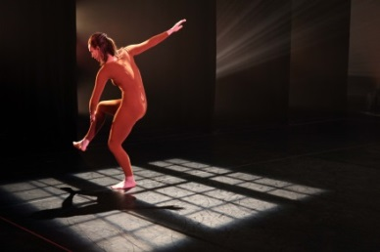
Trisha Brown Dance Company - For M.G.:The Movie (1991) – Foto di Julieta Cervantes
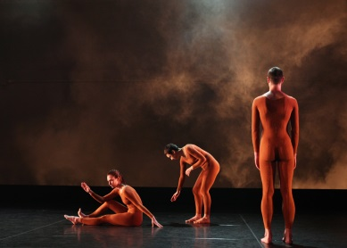
Trisha Brown Dance Company - For M.G.:The Movie (1991) – Foto di Julieta Cervantes
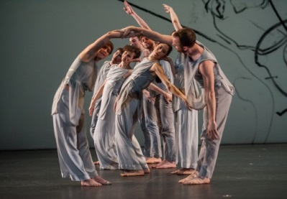
Trisha Brown Dance Company - Les Yeaux et l’ame – Foto di Stephanie Berger

